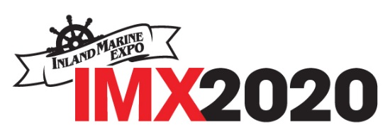

FOR IMMEDIATE RELEASE
Contact: Your Name & Organization
Phone: Contact Phone Number
Email: Contact Email Address

(COMPANY NAME) INTRODUCES NEW PRODUCTS AT IMX2020 Virtual
(Main Headline)

Rooted in Tradition, Propelled by Innovation
(Italicized Sub-header)

[CITY, STATE, Month Date—] (Company name) has recently announced a new line of (product name). They will debut these exciting new products at the Inland Marine Expo, produced by The Waterways Journal, the 100% online trade show and conference for the inland and intracoastal marine transportation industry, debuting September 29th. (Company name) will host a 3D virtual exhibit booth (insert booth hall or category) where attendees can access product information, interact with company personnel, and place orders. (Opening paragraph should include the most important information; typically, the “who, what, where, when and how.)

“We’re excited to introduce this new line to the market,” says (insert name and title) at (Company name). “Our customers have been asking for products with these new features and we are proud to be able to provide them.” Inland Marine Expo (IMX) will provide an exciting new venue where attendees can experience products in a 3-D environment and engage with exhibitors. “Our participation at IMX2020 Virtual enables our staff to engage with customers, answer questions, and take orders in a real-time environment,” added (last name).

(Include additional details about the product, what makes it unique, quote from a company executive or key subject matter expert. Add additional relevant facts and comments here.)

About (Company Name)
Provide a brief description of what your company does, how long you have been in business. Include URL link to your website.

About IMX2020 Virtual:
The Inland Marine Expo is focused on honoring the brown water community’s rich history and providing the modern workforce with the tools, education and inspiration it needs to propel forward. #IMX2020 is presented by The Waterways Journal and is designed specifically for the inland and intracoastal marine transportation industry. From CEOs to deckhands, this annual event is for the whole team. Registration is now open & FREE to attend. Visit inlandmarineexpo.com to learn more.

Send your press release to industry media contacts and any local, state, or national media contacts you might have.

